**Topics: Descriptive Statistics and Probability**

1. Look at the data given below. Plot the data, find the outliers and find out $μ, σ, σ^{2}$

|  |  |
| --- | --- |
| **Name of company** | **Measure X** |
| Allied Signal | 24.23% |
| Bankers Trust | 25.53% |
| General Mills | 25.41% |
| ITT Industries | 24.14% |
| J.P.Morgan & Co. | 29.62% |
| Lehman Brothers | 28.25% |
| Marriott | 25.81% |
| MCI | 24.39% |
| Merrill Lynch | 40.26% |
| Microsoft | 32.95% |
| Morgan Stanley | 91.36% |
| Sun Microsystems | 25.99% |
| Travelers | 39.42% |
| US Airways | 26.71% |
| Warner-Lambert | 35.00% |

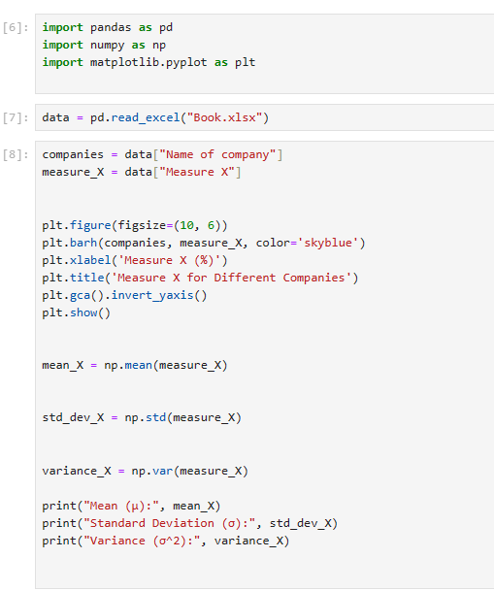

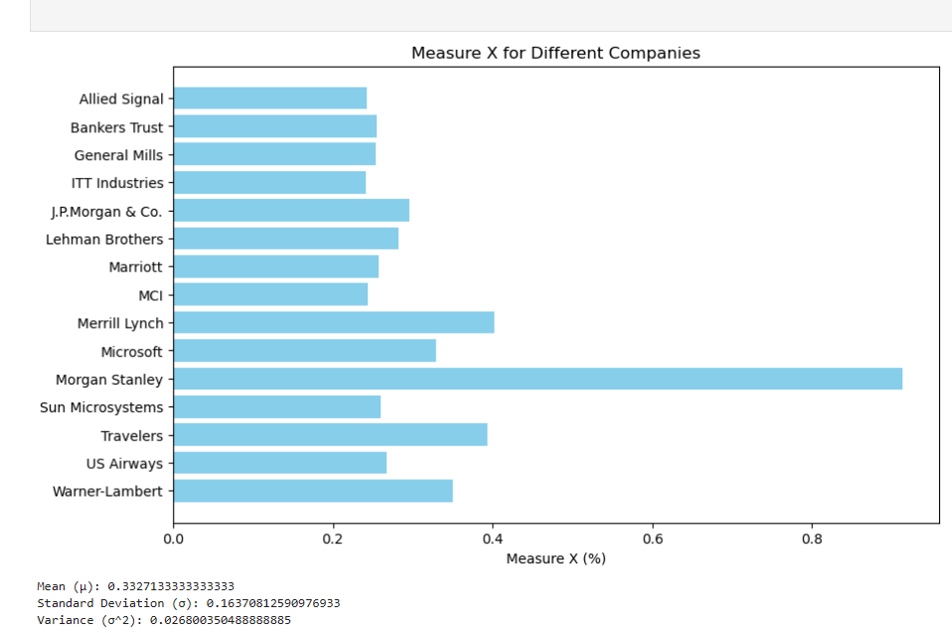



Answer the following three questions based on the box-plot above.

1. What is inter-quartile range of this dataset? (please approximate the numbers) In one line, explain what this value implies.

IQR = 12- 5 =7

IQR represents the spread or dispersion of the middle 50% of the dataset

1. What can we say about the skewness of this dataset?

The median line is closer to the lower end of the box and the right whisker is longer, it suggests that the data is positively skewed

1. If it was found that the data point with the value 25 is actually 2.5, how would the new box-plot be affected?

The corrected value of 2.5 instead of 25 would shift the lower end of the dataset downward, likely shortening the lower whisker and potentially altering the position of the median line. This adjustment could also affect the classification of outliers and the overall spread and skewness of the data.



Answer the following three questions based on the histogram above.

1. Where would the mode of this dataset lie?

5

1. Comment on the skewness of the dataset.

Positively Skewed

1. Suppose that the above histogram and the box-plot in question 2 are plotted for the same dataset. Explain how these graphs complement each other in providing information about any dataset.

Both Graph tells that they are Positively Skewed and having outlier

1. AT&T was running commercials in 1990 aimed at luring back customers who had switched to one of the other long-distance phone service providers. One such commercial shows a businessman trying to reach Phoenix and mistakenly getting Fiji, where a half-naked native on a beach responds incomprehensibly in Polynesian. When asked about this advertisement, AT&T admitted that the portrayed incident did not actually take place but added that this was an enactment of something that “could happen.” Suppose that one in 200 long-distance telephone calls is misdirected. What is the probability that at least one in five attempted telephone calls reaches the wrong number? (Assume independence of attempts.)

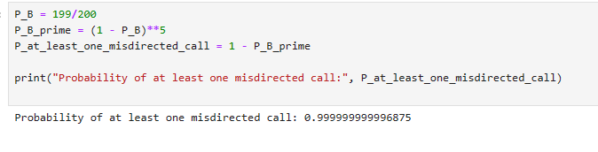

1. Returns on a certain business venture, to the nearest $1,000, are known to follow the following probability distribution

|  |  |
| --- | --- |
| x | P(x) |
| -2,000 | 0.1 |
| -1,000 | 0.1 |
| 0 | 0.2 |
| 1000 | 0.2 |
| 2000 | 0.3 |
| 3000 | 0.1 |

1. What is the most likely monetary outcome of the business venture?

The return value with the highest probability is $2000, occurring with a probability of 0.3. Therefore, the most likely monetary outcome of the business venture is $2000.

1. Is the venture likely to be successful? Explain

success is defined as achieving a positive return, then yes, the venture is likely to be successful since the probabilities associated with positive returns (0, $1000, $2000, $3000) sum up to 0.8 (or 80%).

1. What is the long-term average earning of business ventures of this kind? Explain

long-term average earning of business ventures of this kind is $800.

1. What is the good measure of the risk involved in a venture of this kind? Compute this measure

A good measure of the risk involved in a venture of this kind is the standard deviation of the returns. It provides a measure of the dispersion or variability of the returns around the mean return.

